Kentucky Cancer Registry
  - New ReGISTRAR TRAINING PACKET

Task | Date completed | Initials
CPDMS.net access, database introduction and Operator’s Manual
KCR FES acct access and process
KCR websites: Web Help Abstractor’s Manual, Wiki page, KCR newsletters, training webinars including NAACCR password protected webinars
Blank abstract forms
KCR web portal: E-path, TX report, activity reports, survivorship care plan
Casefinding requirements including ambiguous terminology list
ICD-O-3 Manual
Class of Case
Staging Systems: AJCC TNM, Collaborative Stage, Summary Stage
Collaborative Staging Manual
AJCC Manual
April Fritz Case books I and II
First course therapy
Follow-up
Multiple Primary and Histology Rules
SINQ I&R/SEER Rx database/SEER educate, SEER Appendix C (SEER Website)
FORDS Manual including surgery codes
COC program standards manual/website (www.facs.org)
Hematopoietic & Lymphoid Neoplasm Case reportability & Coding Manual (SEER website)
CAnswer Forum
NAACCR
NCRA
CAP website for protocols/reference
NCCN guidelines
New Abstractor’s Training (2-3 days)
Operator’s Training (1-2) days
KCR regional coordinator site visits and processes
CPDMS summary reports
Errata reports
KCR Spring Training and Fall Workshop
Epath audits from Lisa Witt & PMCs from Vicki LaRue
Death Clearance follow-back from Lindsey Baker
Text templates for entering cases
Links to websites

CPDMS.net access, database introduction and Operator’s Manual
You will received CPDMS.net access, FES account access, and Wiki page access from our IT staff through your regional coordinator. https://cpdms.net/cpdms
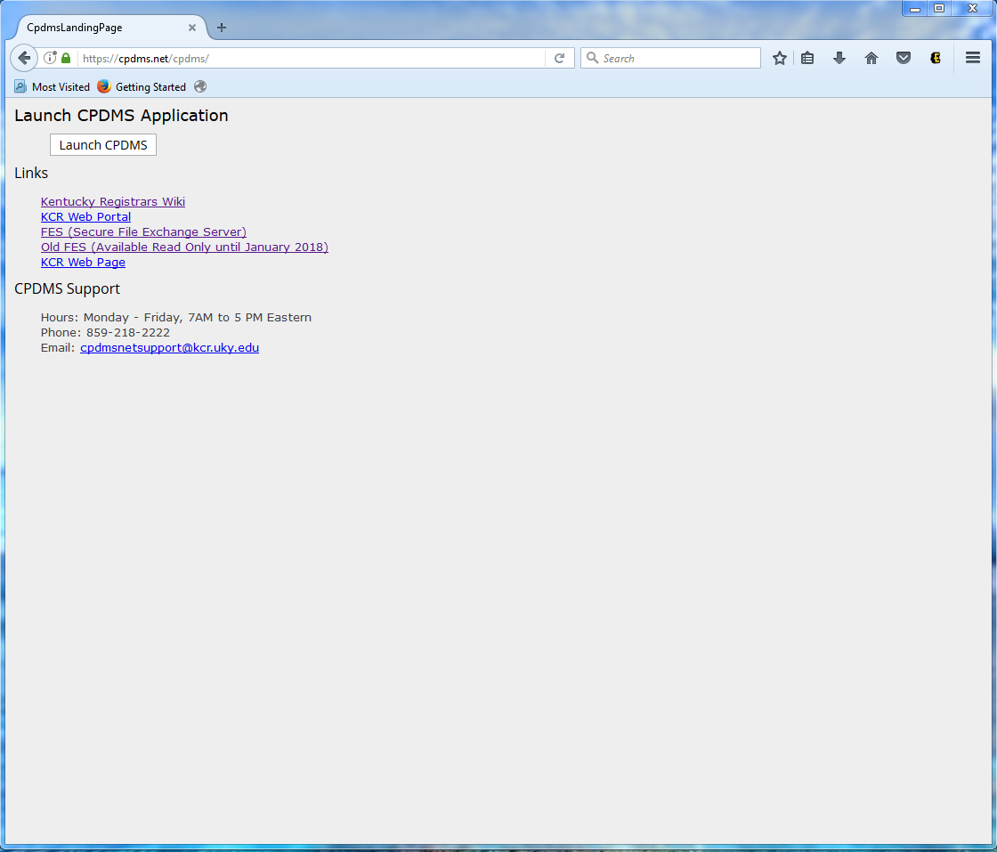
Please be looking through the Operator’s Manual located at: http://www.kcr.uky.edu/manuals/
On the Manuals page you will find the 2017 web help version of the Abstractor’s Manual and Operator’s Manual a downloadable printable version of the Abstractor’s Manual. You can also find a copy of a blank abstract form for your use.
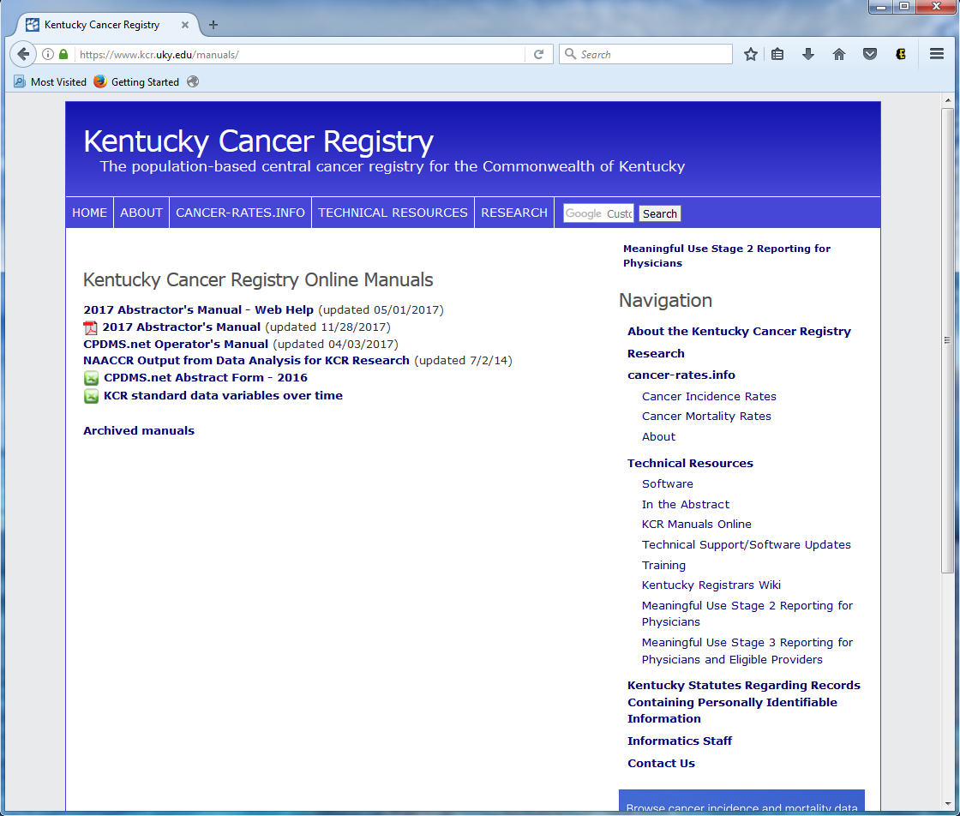

Secure File Transfer to and from KCR (FES Accounts)
Secure file transfer instructions (FES accts)
Go to https://fes.uky.edu

Your user ID and password will be the same as you use for CPDMS access
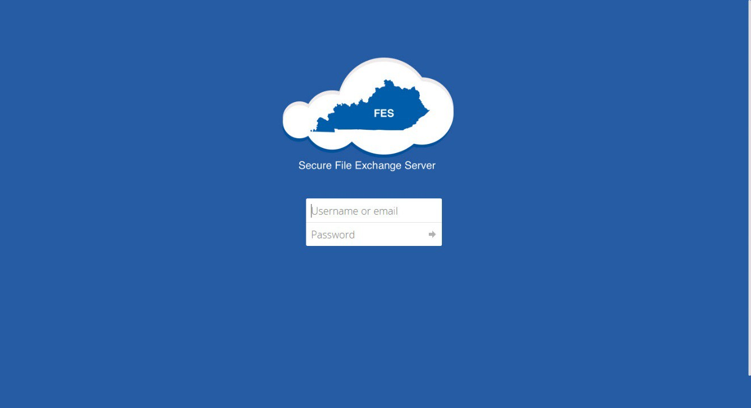
A successful login will take you to this screen:
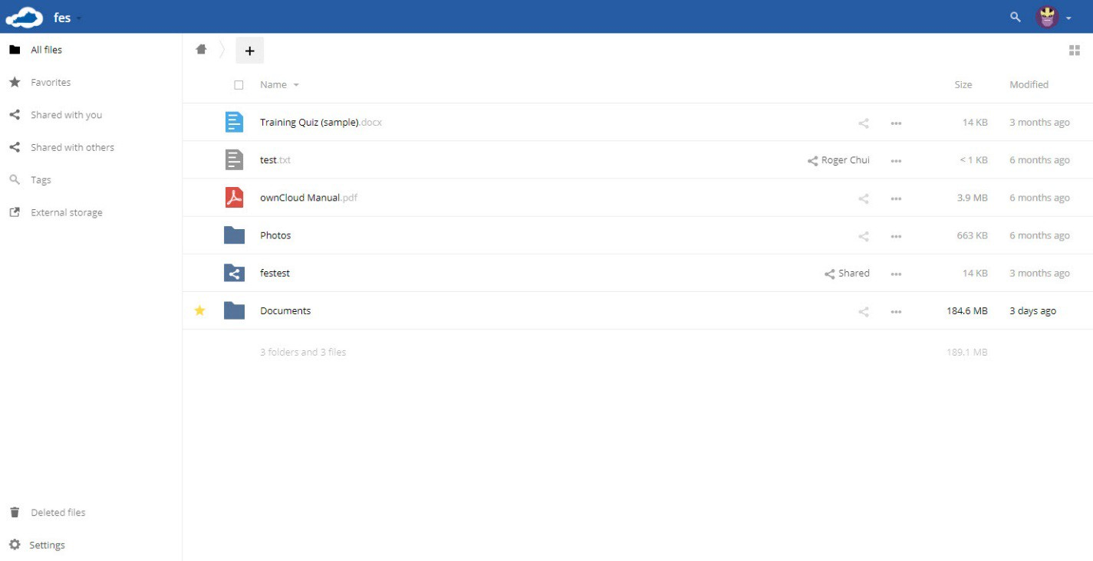

User Settings
To set or adjust your user settings, go over to the top right corner and click the downward arrow:
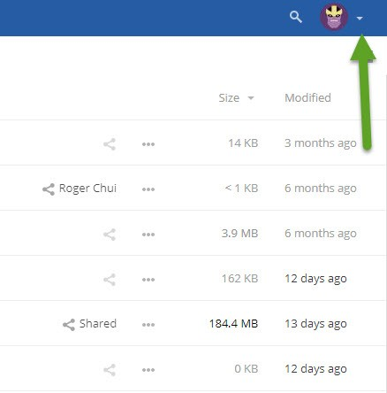
From there, select personal
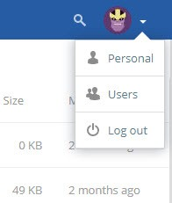

This will take you to the following screen:

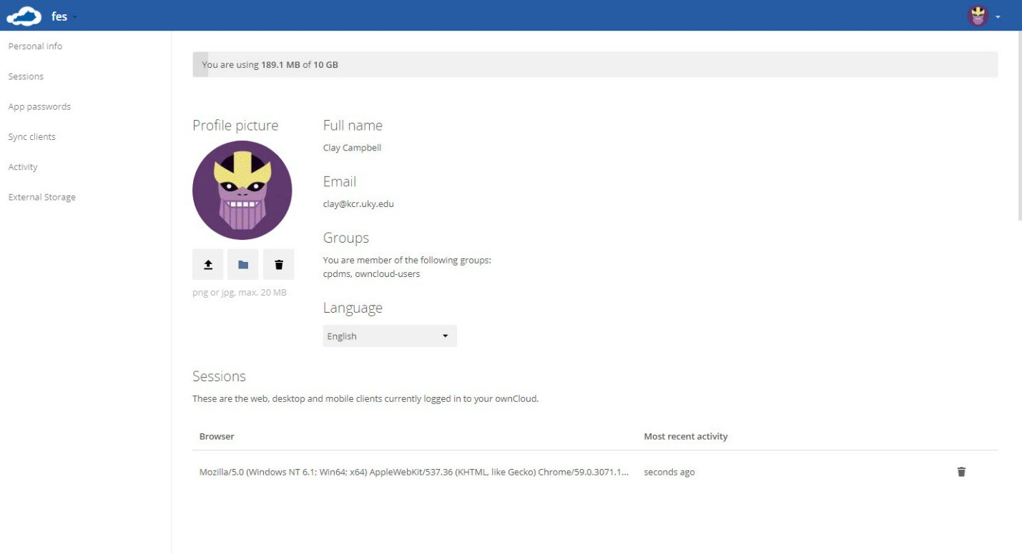

Scroll down from here, and you will come to a section that deals with alerts that you can customize:
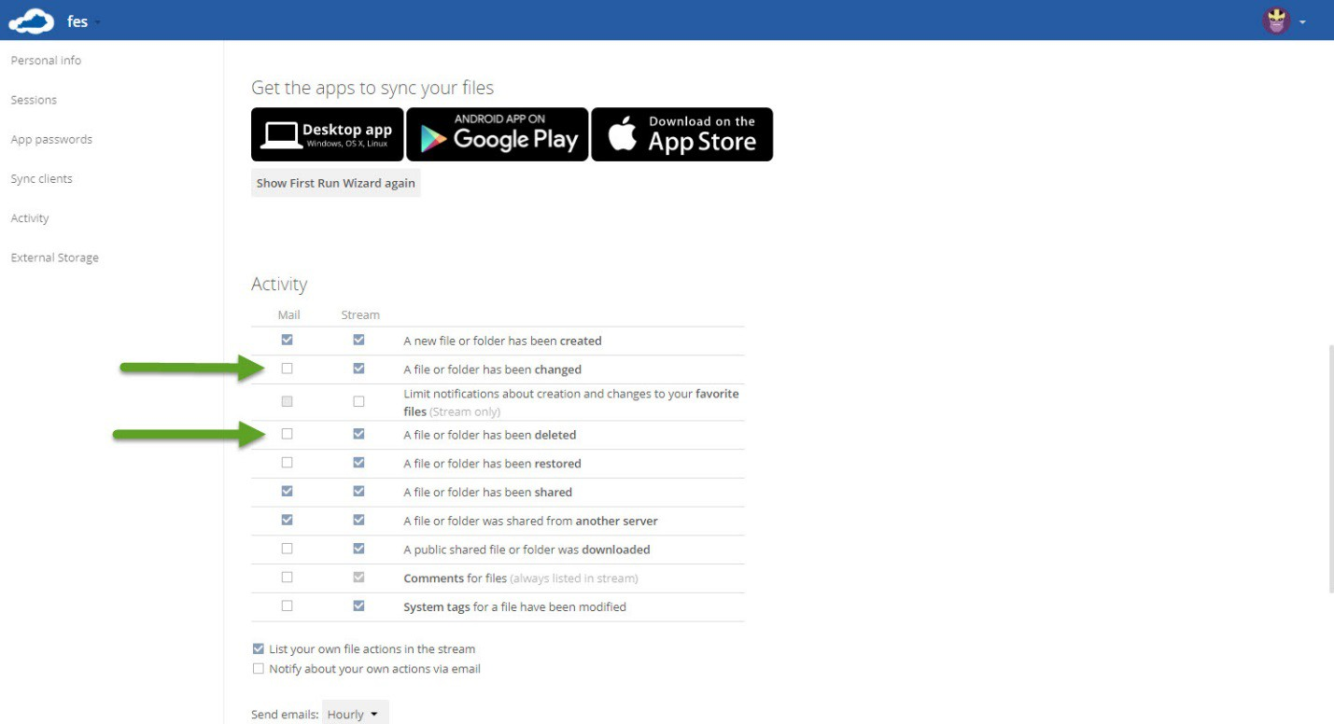
In this area, it is highly encouraged to select the 2 boxes that have the arrows next to them. This will notify you if files are changed or deleted.

Create a new folder
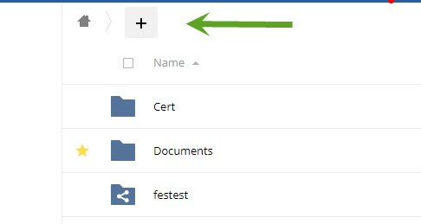
To create a new folder: click the plus sign at the top
then select folder
Name the folder and hit enter, this will create your new folder.

Sharing Files
To share a folder or file, select the triangle to the right of the file or folder name:
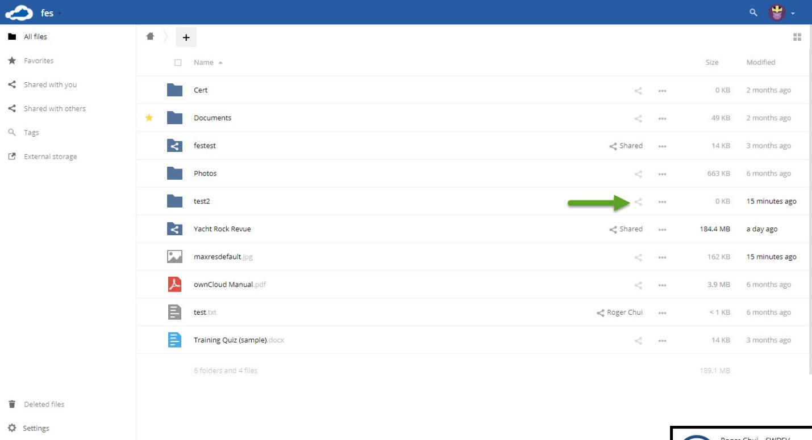
Clicking on this will open the share options. From here you will enter the name of the person or group you want to share files with
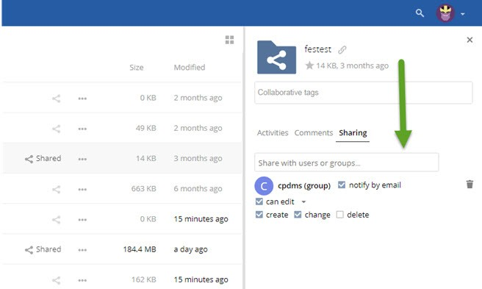

Sharing Files cont.
Check the “notify by email” box. If you want this to be a read only folder, uncheck can edit. To give access to upload or delete, leave can edit checked, click the little triangle next to it, and select either create, change, or delete. At this point you have shared the folder or item. To cancel the share, click the trashcan to the right in the share option area.

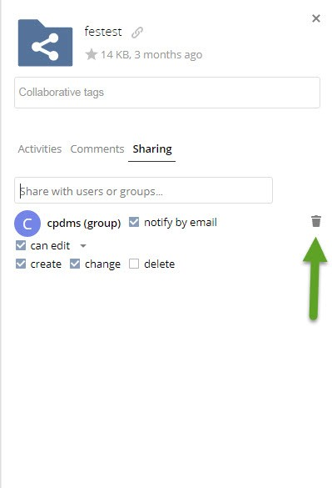

See activity on your account
To see files you have shared, ones that have been shared to you or edited/deleted activity, click the arrow to the right of fes in the left corner of your screen:
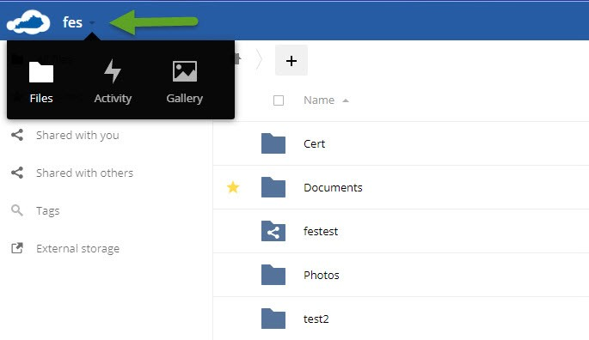
Then select Activity to take you to activity page. This will show you any activities by you or others to you, and can also list all the shared files or folders you have access to:
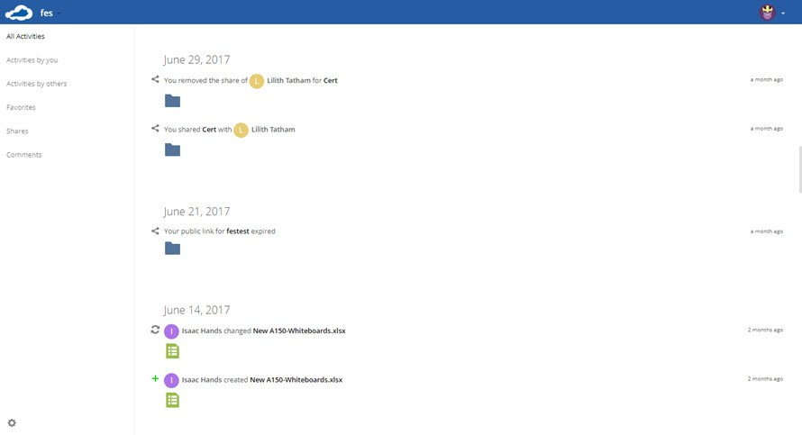

Kentucky Registrar’s Wiki Page
Registrar's Wiki link from CPDMS main window
The wiki page has registrar contact information, information regarding training, and other useful registrar information.

Kentucky Cancer Registry Web Portal
KCR web portal: https://portal.kcr.uky.edu/ or accessible through CPDMS main window
The web portal contains E-path, TX report, activity reports, and survivorship care plans.
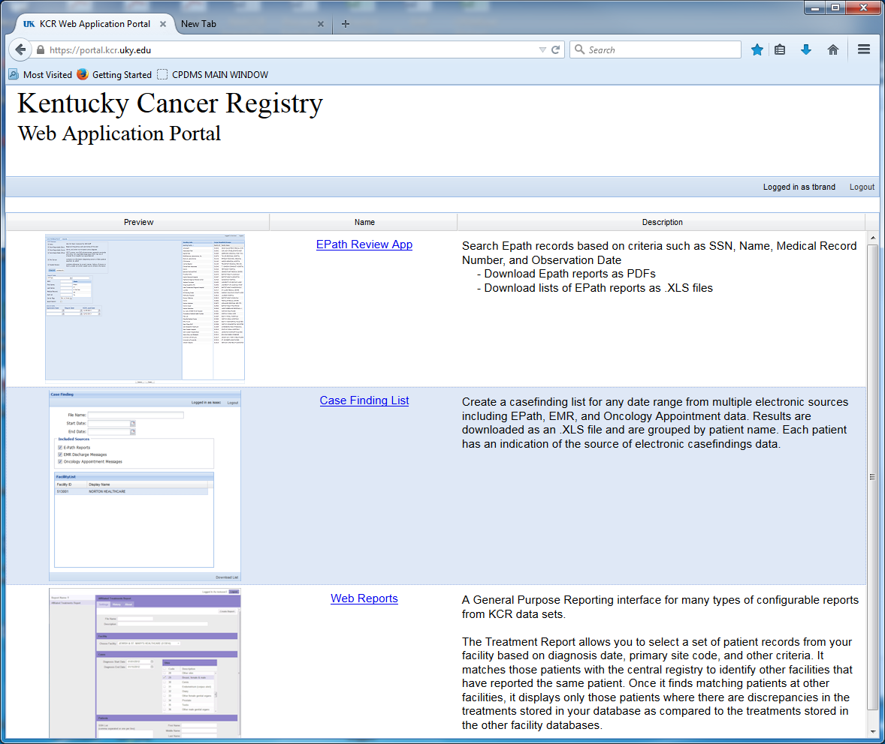
Casefinding requirements
All participating institutions should establish procedures for complete casefinding within their institution. In many hospitals, records are housed in one location (i.e., the medical records department). In others, procedures for identifying patients from multiple independent ancillary service areas may be necessary (i.e., outpatient clinics, radiation therapy, etc). It is important that the following multiple sources in the hospital be searched to keep missed reportable cases to a minimum. The procedures outlined below should be adapted to each individual hospital.
1. Medical record disease discharge diagnostic index:
Any patient record coded with the diagnoses listed below should be reviewed to determine if the case is one which meets KCR reportability criteria. Note that a diagnosis is not necessarily reportable simply because it falls within the codes below; refer to the Case Reportability Requirements to make sure the case is truly reportable to KCR.

ICD-10-CM Codes (Effective 10-01-2017 through 09-30-2018)
REPORTABLE NEOPLASMS
ICD-10 CODE | EXPLANATION OF CODE
C00.- - C43.-, C4A.-,  C45.- - C48.-, C49.- -  C96.- | Malignant neoplasms (excluding category C44 and C49.A), stated or presumed to be primary (of specified site) and certain specified histologies  NEW for FY2018:  C96.20 Malignant mast cell neoplasm, unspecified  C96.21 Aggressive systemic mastocytosis  C96.22 Mast cell sarcoma  C96.29 Other malignant cell neoplasm
C44.00, C44.09 | Unspecified/other malignant neoplasm of skin of lip
C44.10-, C44.19- | Unspecified/other malignant neoplasm of skin of eyelid
C44.20-, C44.29- | Unspecified/other malignant neoplasm skin of ear and external auricular canal
C44.30-, C44.39- | Unspecified/other malignant neoplasm of skin of other/unspecified parts of face
C44.40, C44.49 | Unspecified/other malignant neoplasm of skin of scalp & neck
C44.50-, C44.59- | Unspecified/other malignant neoplasm of skin of trunk
C44.60-, C44.69- | Unspecified/other malignant neoplasm of skin of upper limb, incl. shoulder
C44.70-, C44.79- | Unspecified/other malignant neoplasm of skin of lower limb, including hip
C44.80, C44.89 | Unspecified/other malignant neoplasm of skin of overlapping sites of skin
C44.90, C44.99 | Unspecified/other malignant neoplasm of skin of unspecified sites of skin
C49.A- | Gastrointestinal Stromal Tumors  Note: GIST is only reportable when it is malignant (/3). GIST, NOS (not stated whether malignant or benign) is a /1 and is not reportable.
D00.- - D09.- | In-situ neoplasms  Note: Carcinoma in situ of the cervix (CIN III-8077/2) and Prostatic Intraepithelial Carcinoma (PIN III-8148/2) are not reportable
D18.02 | Hemangioma of intracranial structures and any site
D32.- | Benign neoplasm of meninges (cerebral, spinal and unspecified)
D33.- | Benign neoplasm of brain and other parts of central nervous system
D35.2 - D35.4 | Benign neoplasm of pituitary gland, craniopharyngeal duct and pineal gland
D42.-, D43.- | Neoplasm of uncertain or unknown behavior of meninges, brain, CNS
D44.3 - D44.5 | Neoplasm of uncertain or unknown behavior of pituitary gland, craniopharyngeal duct and pineal gland
D45 | Polycythemia vera (9950/3)  ICD-10-CM Coding instruction note: Excludes familial polycythemia (C75.0), secondary polycythemia (D75.1)
D46.- | Myelodysplastic syndromes (9980, 9982, 9983, 9985, 9986, 9989, 9991, 9992)
D47.02 | Systemic mastocytosis  Note: Effective 10/1/2017
D47.1 | Chronic myeloproliferative disease (9963/3)  ICD-10-CM Coding instruction note: Excludes the following: Atypical chronic myeloid leukemia BCR/ABL-negative (C92.2_), Chronic myeloid leukemia BCR/ABL-positive (C92.1_), Myelofibrosis & Secondary myelofibrosis (D75.81), Myelophthisic anemia & Myelophthisis (D61.82)
D47.3 | Essential (hemorrhagic) thrombocythemia (9962/3)  Includes: Essential thrombocytosis, idiopathic hemorrhagic thrombocythemia
D47.4 | Osteomyelofibrosis (9961/3)  Includes: Chronic idiopathic myelofibrosis, Myelofibrosis (idiopathic) (with myeloid metaplasia), Myelosclerosis (megakaryocytic) with myeloid metaplasia), Secondary myelofibrosis in myeloproliferative disease
D47.Z- | Neoplasm of uncertain behavior of lymphoid, hematopoietic and related tissue, unspecified (9960/3, 9970/1, 9971/3, 9931/3)
D47.9 | Neoplasm of uncertain behavior of lymphoid, hematopoietic and related tissue, unspecified (9970/1, 9931/3)
D49.6, D49.7 | Neoplasm of unspecified behavior of brain, endocrine glands and other CNS
R85.614 | Cytologic evidence of malignancy on smear of anus
R87.614 | Cytologic evidence of malignancy on smear of cervix
R87.624 | Cytologic evidence of malignancy on smear of vagina
¹ Note: Pilocytic/juvenile astrocytoma M-9421 moved from behavior /3 (malignant) to /1 (borderline malignancy) in ICD-O-3. However, SEER registries will CONTINUE to report these cases and code behavior as /3 (malignant).
Follow this link for a casefinding list of reportable ICD-10 codes effective 10/01/2017, which includes a comprehensive list plus a supplemental list. https://seer.cancer.gov/tools/casefinding/case2018-icd10cm.html
2. Pathology reports:
All pathology reports on both inpatients and outpatients should be reviewed for case reportability. Since most cancer patients have a biopsy or operative resection performed, nearly all of the reportable cases can be identified through pathology reports alone. Histologic diagnoses are based upon microscopic examination of tissue taken from such procedures as biopsy, frozen section, surgery, or D & C. Expand path report screening to include benign CNS tumors, beginning with 1-1-04 diagnoses. Check for cases of anal intraepithelial neoplasia, grade III (AIN III), ductal intraepithelial neoplasia 3 (DIN 3), vaginal intraepithelial neoplasia, grade III (VAIN III), and vulvar intraepithelial neoplasia, grade III (VIN III).
NOTE: Path reports may be the best source for finding cases of VIN, VAIN, and AIN (8077/2) and DIN (8500/2).
3. Cytology reports:
All cytology reports for both inpatients and outpatients should be reviewed for case reportability. Cytologic diagnoses are based upon microscopic examination of cells as contrasted with tissues. Included are smears from sputum, bronchial bushings, bronchial washings, tracheal washings, prostatic secretions, breast secretions, gastric fluid, spinal fluid, peritoneal fluid, pleural fluid, and urinary sediment. Cervical and vaginal smears are common examples.
4. Autopsy reports.
5. Radiation Therapy Department logs.
6. Medical Oncology Department logs.
7. Outpatient Department:
New patient registration rosters, clinic appointment books, surgery schedules, diagnostic imaging, and billing departments are additional casefinding sources.
8. Alpha listing of previously included cases:
Casefinding cannot be considered complete until the CPDMS.net accession list and any previous registry accession lists have been checked to be sure that this is a new patient or a new primary.
Creating and Maintaining a Non-reportable List
In the course of routine casefinding activities, cases which are found to be non-reportable by your hospital should be added to a non-reportable list. The list should consist of each patient’s name, DOB, SSN, medical record number, the type/site of cancer, and a brief explanation of why the case is not reportable to the hospital registry (i.e., "patient was seen for consult only, no dx or tx," or "patient originally diagnosed prior to reference date"). A well-maintained non-reportable list will save registrars time by preventing them from reviewing a chart multiple times to check on a particular primary that does not need to be abstracted. The list can be invaluable during casefinding audits by allowing quick resolution of possible missed cases. It is also helpful during the death clearance process.
Bear in mind that cases which are not reportable by your hospital, but which ARE reportable to KCR (see Case Reporting Requirements) should be sent to the central registry to be abstracted there. These may include:
• A specimen from an outside doctor’s office which was sent to your hospital’s path lab
• Any case that was diagnosed and/or treated only in a nonhospital facility
• A Kentucky resident who was initially diagnosed or treated out of state

Ambiguous terminology
According to the Reporting Requirements, all cases of primary malignant disease diagnosed or treated at a Kentucky hospital on or after January 1, 1991 are required to be included. These are usually described by the terms: carcinomas, sarcomas, melanomas, leukemias, and lymphomas. The primary reference book which lists all malignant diseases is the International Classification of Diseases for Oncology (ICD-O), third edition. In addition to providing a list of all morphologies considered to be malignant (or cancerous), the ICD-O book also contains cell behavior codes: 0=benign, 1=borderline malignancy, 2=in-situ, 3=malignant primary, 6=malignant metastasis, and 9=malignant, unknown if primary or metastatic. All malignancies with a behavior code of 2 or 3 in ICD-O, 3rd edition, should be included in the registry, except specified neoplasms of the skin and pre-invasive cervical neoplasia, as described in Case Reporting Requirements. Benign and borderline CNS tumors diagnosed on or after January 1, 2004 are required to be reported.
Other benign tumors and borderline malignancies (behavior codes 0 and 1) may be listed in the registry in a separate accession register. They should not be entered into CPDMS.net. These diagnoses are referred to as "reportable-by-agreement" cases.
Metastatic tumors and tumors that are unknown if primary or metastatic (behavior codes 6 and 9) are indicative of a primary malignancy of an unknown site. These cases should be reported with the primary site coded as "unknown primary" (topography code of C80.9) and the appropriate morphology code with a behavior code of /3.
1. Inconclusive diagnostic terms
Occasionally the diagnosis contains vague or inconclusive terms, such as probable carcinoma of the lung. The following terms are considered to be diagnostic of cancer if they modify a term such as malignancy or carcinoma:
apparent(ly)
appears
compatible with
comparable with
consistent with
favor(s)
most likely
malignant appearing
most likely
presumed
probable
suspect(ed)
suspicious (for)
typical of

EXCEPTION: If a cytology report says "suspicious," do not interpret it as a diagnosis of cancer. Abstract the case only if a positive biopsy or a physician's clinical impression of cancer supports the cytology. The diagnosis date is date of supporting documentation - either physician statement or positive biopsy.
If a term does not appear on the above list, or is not a form of a word on this list, the term is not diagnostic of cancer. Do not accession the case. Examples of forms of a word are "favored" rather than "favor(s)" and "appeared to be" rather "appears." Do not substitute synonyms such as "supposed" for "presumed" or "equal" for "comparable."
Any other ambiguous terminology regarding the diagnosis of a malignancy is not to be interpreted as diagnostic of cancer. Some examples are:

cannot be ruled out
equivocal
likely
lump
lytic lesion (on x-ray)
mass
neoplasm*
nodule
possible
potentially malignant
questionable
rule out
suggests

tumor*
worrisome

For example, a diagnosis of probable carcinoma of the left lung would be abstracted as a lung primary. A possible carcinoma is not reportable.
*EXCEPTION: For benign and borderline brain and CNS tumors, the terms "tumor" and "neoplasm" will be considered diagnostic of a reportable disease.
2. Changing the diagnosis
Over time, information may be added to the patient's medical chart that was missing or ambiguous in the original record. It is the practice to accept the thinking and information about the case based on the latest or most complete information. Thus, it is acceptable to change the primary site and histology as information becomes more complete. However, information about the Collaborative Stage and extent of disease at diagnosis may only be changed as long as the new information reflects the time period within four months of the date of diagnosis in the absence of disease progression or through first course surgeries, whichever is longer.
There may be cases reported originally as cancer with the ambiguous terms listed previously, which later information indicates never were malignancies. These cases must be deleted from the file, and the sequence number of any remaining cases for the same person adjusted accordingly.

ICD-0-3 Manual
http://www.ctrexam.org/resources/index.htm - If you click on the ICD-0-3 link you can get an electronic version of the ICD-0-3 manual
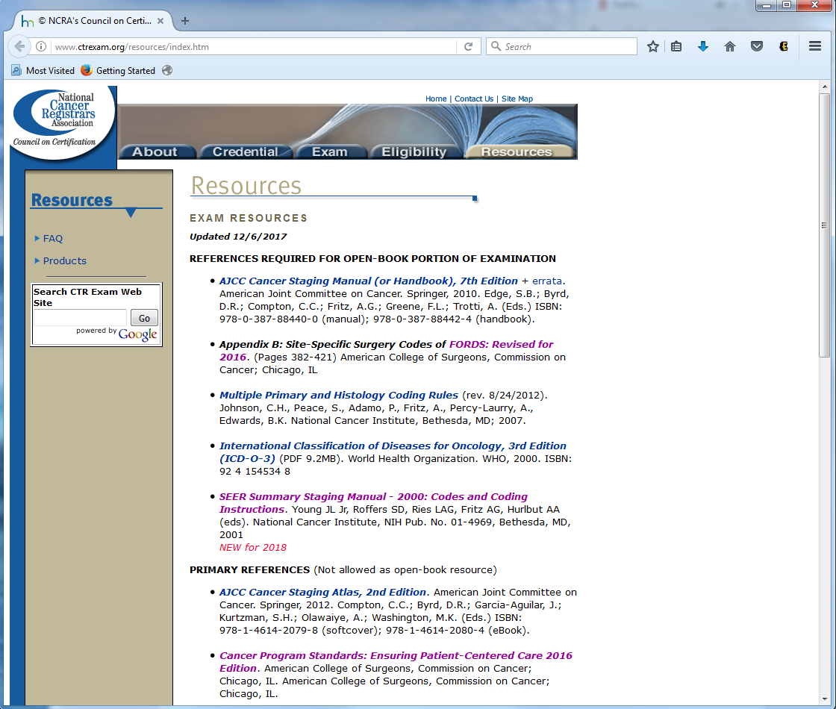

Class of Case
Class of case reflects the facility's role in managing this cancer, whether the cancer is required to be reported to ACoS by approved facilities, and whether the case was diagnosed after the program's reference date. Enter the two digit code that describes the patient's relationship to the facility.
Instructions for Coding
- Code 00 applies only when it is known that the patient went elsewhere for treatment. If that information is not available, code class of case '10.' It is possible that information for coding class of case will change during the patient's first course of care. If that occurs, edit the code accordingly.
- ACoS approved facilities should document Institution Referred To (item #31660) for patients coded 00 to establish that the patient went elsewhere for treatment.
- A staff physician (codes 10-12, 41) is a physician who is employed by the reporting facility, under contract with it, or who has routine practice privileges there.
- Refer to the "Case Reporting Requirements" section of this manual for a discussion of Classes and KCR requirements.
Codes
Analytic Classes of Case (Required by CoC to be abstracted by accredited programs)
Code | Description
 | Initial diagnosis at reporting facility
00 | Initial diagnosis at the reporting facility AND all treatment or a decision not to treat was done elsewhere
10 | Initial diagnosis at the reporting facility or in a staff physician's office AND part or all of first course treatment or a decision not to treat was at the reporting facility, NOS
11 | Initial diagnosis in staff physician's office AND part of first course treatment was done at the reporting facility
12 | Initial diagnosis in staff physician's office AND all first course treatment or decision not to treat was done at the reporting facility
13 | Initial diagnosis at the reporting facility AND part of first course treatment was done at the reporting facility
14 | Initial diagnosis at the reporting facility AND all first course treatment or a decision not to treat was done at the reporting facility
 | Initial diagnosis elsewhere
20 | Initial diagnosis elsewhere AND all or part of first course treatment was done at the reporting facility, NOS
21 | Initial diagnosis elsewhere AND part of first course treatment was done at the reporting facility
22 | Initial diagnosis elsewhere AND all first course treatment or a decision not to treat was done at the reporting facility
Non-analytic Classes of Case (Not required by CoC to be abstracted by accredited programs, but may be required by KCR)
 | Patient appears in person at reporting facility
30 | Initial diagnosis and all first course treatment elsewhere AND reporting facility participated in diagnostic workup (i.e., consult only or staging workup)
31 | Initial diagnosis and all first course treatment elsewhere AND reporting facility provided in-transit care
32 | Diagnosis AND all first course treatment provided elsewhere AND patients presents at reporting facility with disease recurrence or persistence
33 | Diagnosis AND all first course treatment provided elsewhere AND patient presents at reporting facility with disease history only
34 | Type of case not required by CoC to be accessioned (i.e., CIS of the cervix) AND initial diagnosis AND part or all of first course treatment by reporting facility
35 | Case diagnosed before program's reference date AND initial diagnosis AND all or part of first course treatment by reporting facility
36 | Type of case not required by CoC to be accessioned (i.e., CIS of the cervix) AND initial diagnosis elsewhere AND all or part of first course treatment by reporting facility
37 | Case diagnosed before program's reference date AND initial diagnosis elsewhere AND all or part of first course treatment by facility
38 | Initial diagnosis established by autopsy at the reporting facility, cancer not suspected prior to death
Patient does not appear in person at reporting facility
Do not abstract cases in class 40 - 99- refer them to KCR; these classes are for KCR use only
40 | Diagnosis AND all first course treatment given at the same staff physician's office
41 | Diagnosis and all first course treatment given in two or more different staff physician offices
42 | Nonstaff physician or non-CoC accredited clinic or other facility, not part of reporting facility, accessioned by reporting facility for diagnosis and/or treatment by that entity (i.e., hospital abstracts cases from an independent radiation facility)
43 | Pathology or other lab specimens only
49 | Death certificate only
98 | Non-hospital treatment abstracted by KCR
99 | Non-hospital cases abstracted by KCR

Staging Systems: AJCC TNM, Collaborative Stage, Summary Stage
AJCC Staging
The American College of Surgeons (ACoS) Commission on Cancer has required that all approved programs must TNM stage all sites contained in the AJCC Manual for Staging of Cancer since January 1, 1991. Effective with 1995 cases, all cancers must be coded for the AJCC staging elements both clinically and pathologically.
Clinical extent of disease is based on information and evidence accumulated before cancer-directed treatment. It is based on the physical examination, imaging, endoscopy, biopsy, surgical exploration, and other relevant findings. Clinical classification is appropriate for sites accessible for clinical examination. Use clinical classification when an organ does not have a pathologic evaluation.
Pathologic extent of disease is based on information gathered before cancer-directed treatment, as well as evidence gathered from surgery and pathological examination of the resected specimen. Pathologic extent of disease is a combination of all findings through first course of surgery, or 4 months, whichever is longer, in the absence of disease progression.
2. SEER Summary Stage 2000
The Commission on Cancer also requires Summary Staging for any and all sites not included or not appropriate for AJCC TNM staging. The Kentucky Cancer Registry required Summary Staging 1977 on all cases diagnosed prior to January 1, 2001. On January 1, 2001, the SEER Summary Stage 2000 coding scheme was implemented. This field will be calculated from the data values entered in the SEER Extent of Disease and Collaborative Stage fields, so it does not have to be manually coded.
Extent of disease is limited to all information available through completion of first course surgery(ies) or within four months of diagnosis in the absence of disease progression, whichever is longer.
Summary Stage for all sites is based on pathological, operative, and clinical assessments. The priority for using these reports is:
-Pathologic
-Operative (Particularly important when the surgical procedure does not remove all malignant tissue)
-Clinical
3. Directly Coded Summary Stage 2000
This field is required in 2015, in addition to the derived Summary Stage 2000 field mentioned above.

4. SEER Extent of Disease (EOD)
For cases diagnosed from January 1, 2000 to December 31, 2003, the Kentucky Cancer Registry requires SEER Extent of Disease coding. Extent of Disease should include all information available through completion of surgery(ies) in first course treatment or within four months of diagnosis in the absence of disease progression, whichever is longer.
For all sites, extent of disease is based on a combined clinical and operative/pathological assessment. Use the SEER Extent of Disease Coding Manual, Third Edition (1998) to determine the code values for these fields.
5. Collaborative Staging
Collaborative Staging (CS) is to be used for cases diagnosed on or after January 1, 2004. It is not to be used for cases diagnosed prior to that date. Its introduction does not affect CoC requirements for physicians to assign AJCC staging or the requirement that the physician-assigned staging values be recorded in the registry.
With Collaborative Staging, registrars code discrete pieces of information once and the CS computer algorithm derives the values for AJCC T, N, M and Stage Group, Summary Stage 1977, and Summary Stage 2000. The derived stage codes are ideally suited for data analysis because of the consistency that can be obtained with objectively-recorded, identically-processed data items.
The timing rule for CS coding was designed to make use of the most complete information possible to yield the "best stage" information for the tumor at the time of diagnosis- "use all information gathered through completion of surgery(ies) in first course of treatment or all information available within four months of the date of diagnosis in the absence of disease progression, whichever is longer.” Disease progression is defined as further direct extension or distant metastasis known to have developed after the diagnosis was established. Information about tumor extension, lymph node involvement, or distant metastasis obtained after disease progression is documented, should be excluded from the CS coding.
CS data items are coded by the registrar. The CS algorithm produces the output items listed as derived fields. The derived AJCC items are separate from the physician-coded items; and the derived Summary Stage items are separate from the manually-coded items collected by the CoC in the past. The derived items cannot be manually altered.
Like the AJCC and Summary Stage codes that are derived from it, CS is a site-specific staging system. The CS algorithm uses tumor site and histology to determine which CS schema to apply. Depending on the schema, the coding instructions and code definitions will vary. Collaborative Staging codes are defined for every site and histology combination. The AJCC Cancer Staging Manual does not cover all sites, and some histologies are excluded from sites with an AJCC coding scheme. When the CS algorithm processes a site-histology combination that does not have an applicable AJCC code, it assigns the display string "NA” for "Not applicable.” A blank display string for a derived item means the CS algorithm was not run for the case.

The complete instructions and site-histology defined codes are available in the Collaborative Staging Manual and Coding Instructions. Part I provides general instructions and the instructions and codes for generic (non site-specific) items. Part II contains the site-specific instructions and codes. The CS Manual and related information is available electronically on the AJCC Web site at https://cancerstaging.org/cstage/Pages/default.aspx.
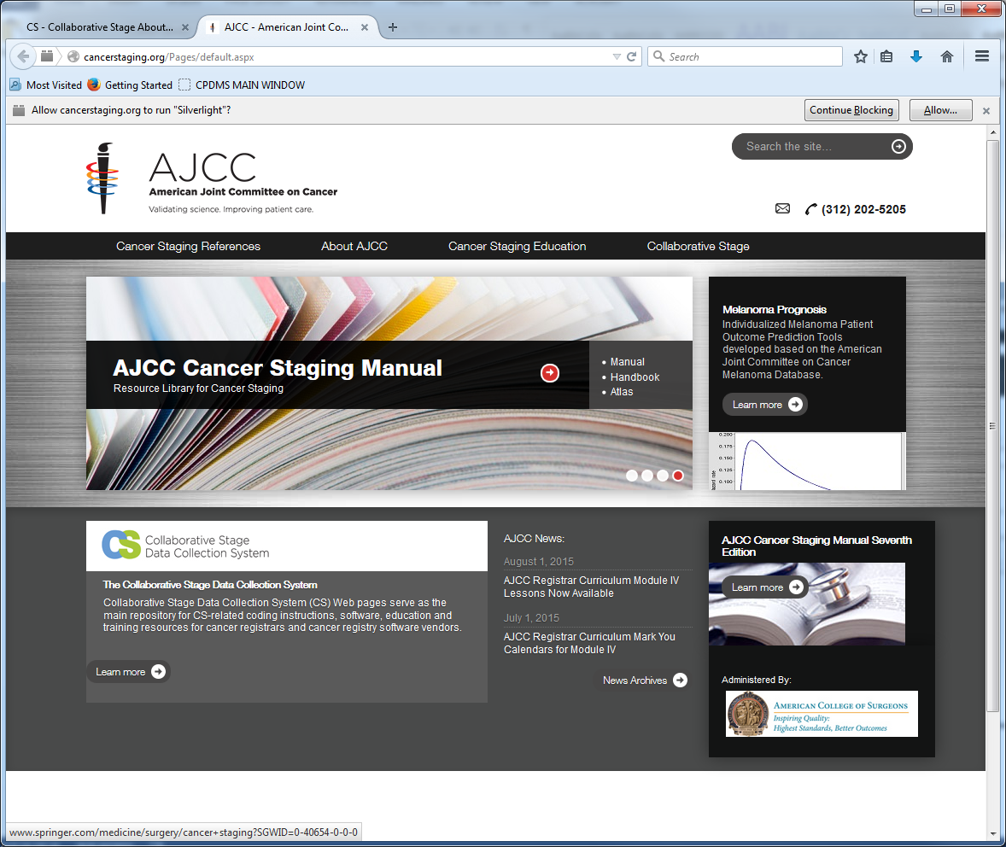
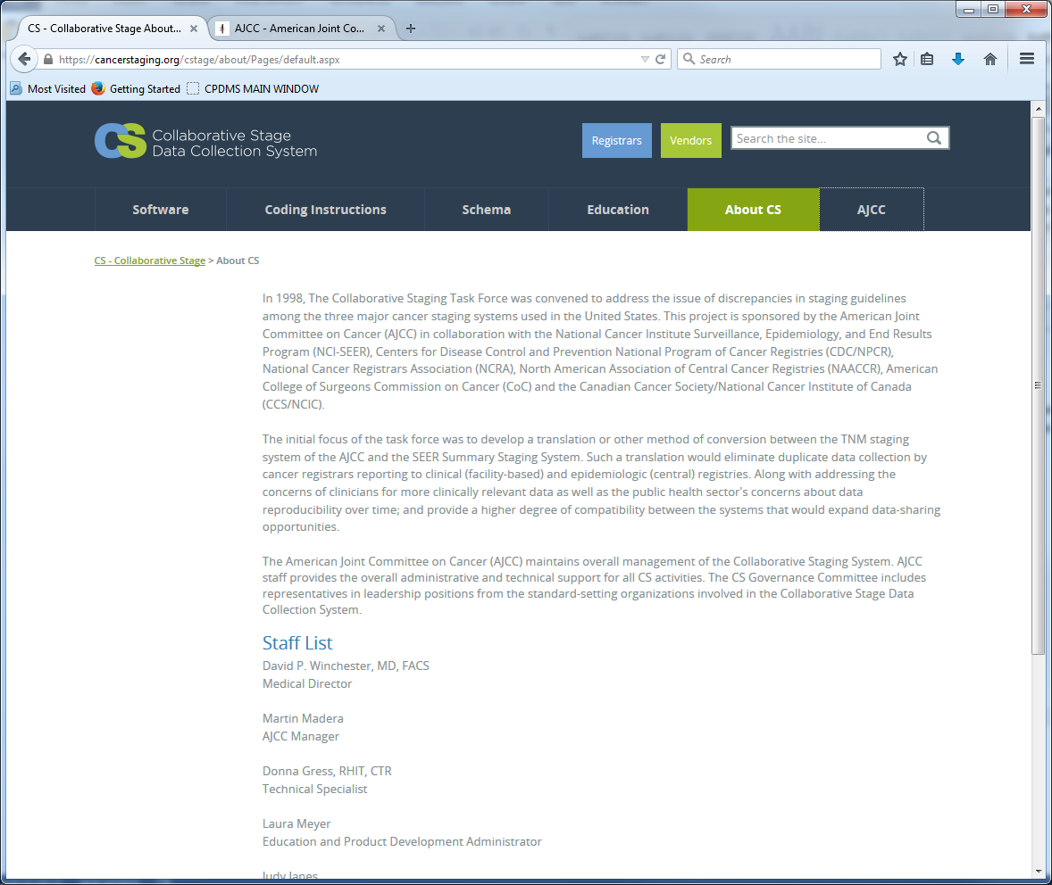

April Fritz Case books I and II
http://www.afritz.org/ - This is the link to the April Fritz Case books I and II

First Course Therapy
1. Treatment Plan
A treatment plan describes the type(s) of treatment(s) intended to modify or control the malignancy. The documentation confirming a treatment plan may be fragmented. It is frequently found in several different sources, i.e., medical record, clinic record, consultation reports, and outpatient records. All cancer-directed treatments specified in the physician(s) treatment plan are a part of the first course of therapy.
A treatment plan may specify only one method of treatment (i.e., surgery) or any combination of therapies (i.e., surgery, radiation therapy, chemotherapy, hormone therapy, immunotherapy, or other therapy). A single regimen includes the combination of concurrent or adjuvant treatments. All treatments specified in the treatment plan and delivered to the patient are first course of therapy.
2. Time Period
All Malignancies Except Leukemia
First course of therapy includes all cancer-directed treatment planned by the physician(s) during or after the first diagnosis of cancer. Planned treatment may include multiple modes of therapy, and may encompass intervals of a year or more. No treatment may be a planned treatment option; therefore, first course of therapy may be No treatment.
When a treatment plan is not available, evaluate the therapy and the time it started. If the therapy is a part of an established protocol or within accepted management guidelines for the disease, it is first course of therapy.
Consult the attending physician or registry's physician advisor if protocols or management guidelines are not available. If there is no treatment plan, established protocol, or management guidelines, and you cannot consult with a physician, use the principle: "first course treatment must begin within four months of the date of initial diagnosis.” Any treatment given after four months is subsequent treatment.
Treatment failure or disease progression may prompt the physician to stop therapy before the full course has been completed. Record any treatments administered after the discontinuation of first course as secondary or subsequent therapy only. If there is no documentation of a treatment plan, a progression, recurrence, or treatment failure, first course ends four months after diagnosis date. Any treatment given after four months is second course treatment in the absence of a documented treatment plan or therapy standard.
Leukemia
Treatment for leukemia is divided into three phases: remission induction, consolidation, and maintenance. Remission induction is initial intensive chemotherapy and/or biological response modifiers. Consolidation is repetitive cycles of chemotherapy and/or irradiation to the brain, given immediately after remission. Maintenance is chemotherapy given for a period of months or even years to maintain remission. Code all therapy that is remission induction, consolidation or maintenance as first course. Do not record treatment that is given after a patient relapses. Some patients do not have a remission. If a patient does not have a remission, record the treatment given in the first attempt to induce a remission. Do not record treatment administered as a change in the original treatment plan.
3. Definitive Treatment
Definitive treatment usually modifies, controls, removes, or destroys proliferating cancer tissue. Treatment may be directed toward either the primary or metastatic sites. Physicians administer the treatment(s) to minimize the size of tumor, or to delay the spread of disease.

NOTE: Only definitive therapy should be included in statistical analyses of treatment. Surgical codes 00-07, and Other treatment code 0 must be excluded. These codes are not considered definitive therapy.
Palliative treatment is treatment that improves the patient’s quality of life by preventing or relieving suffering. Palliative therapy may include definitive treatment procedures as well as non-definitive patient care procedures. For example: The patient was diagnosed with stage IV cancer of the prostate with painful bony metastases. The patient starts radiation treatment intended to shrink the tumor in the bone and relieve the intense pain. The radiation treatments are palliative because they relieve the bone pain; the radiation is also first course of therapy because it destroys proliferating cancer tissue. Record any palliative treatment that modifies or destroys cancer tissue as first course therapy.
4. Non-Definitive Treatment (Non-treatment patient care procedures)
Non-definitive treatments prolong the patient's life, make the patient comfortable, or prepare the patient for definitive therapy. These treatments are not tumor directed. They are not meant to reduce the size of the tumor or delay the spread of disease. Non-definitive procedures include diagnostic procedures and supportive care (treatments designed to relieve symptoms and minimize the effects of the cancer). Non-definitive therapies are generally not used in statistical analysis of treatment.
EXAMPLES:
Surgical procedures:
Incisional biopsies
Exploratory procedures with or without biopsies
Supportive care/relieving symptoms:
Palliative care, including surgery, radiation, and chemotherapy for symptom relief only
Pain medication
Oxygen
Antibiotics administered for an associated infection
Transfusions*
Intravenous therapy to maintain fluid or nutritional balance
Laser therapy directed at relieving symptoms
*NOTE: Coding Treatment for Hematopoietic Diseases: For many of the newly reportable hematopoietic diseases, the principal treatment is either supportive care, observation, or another type of treatment that does not meet the usual definition that treatment "modifies, controls, removes or destroys proliferating cancer tissue.” Such treatments include phlebotomy, transfusions, aspirin, supportive care and observation. In order to document that patients with hematopoietic diseases did have some medical treatment, SEER and the Commission on Cancer have agreed to record these treatments as First Course "Other Treatment” (code 1) for the hematopoietic diseases ONLY. A complete description of the treatment plan should be recorded in the text field for "Other Treatment” on the abstract. For more details, consult the Hematopoietic Database.

Follow-up Policies and Procedures
I. Definition
A. Follow-up of cancer patients is the systematic process of obtaining accurate information at least annually, on the patient's health, vital status, and progression of disease.
Follow-up information is extremely important for the following reasons:
- To assist in the early identification of the recurrence of a cancer.
- To assist the physician in getting former cancer patients to return for scheduled treatments and/or checkups.
- To insure periodic examinations of former cancer patients since they are prone to develop other cancers.
- To gather information so physicians can review various types of treatment in terms of survival.
B. Follow-up information must be sought on analytic cases only (classes 0, 1, and 2), with the following exceptions:
- Patients who are currently residing in foreign countries (New in NAACCR)
- Patients whose only malignancy is carcinoma in situ of the cervix
These are not required to be followed, regardless of the class of the case.
C. Follow-up is considered delinquent by the American College of Surgeons (ACoS) if the information is not successfully obtained and documented within 15 months of the patient's previous date of last contact. A successful follow-up rate of 90% of a hospital's analytic cases is considered in compliance with ACoS standards for an approved Cancer Program. It is best to maintain the highest follow-up rate possible; survival rates and other valuable statistical analyses are heavily dependent on accurate and timely follow-up information.
II. Follow-up information to be collected includes:
A. The date of last contact. This is either the date of death or the most current date the patient was known to be alive.
B. Survival status. This indicates whether the patient is alive (with or without disease) or dead (from causes related or unrelated to cancer).
C. Present address of patient, if different from that originally recorded.
D. Disease Status. This is information about whether the patient was ever disease free, and if so, the start date of the disease free interval.
E. Recurrence information. This includes the date of first recurrence, the type of first recurrence, and the site(s) of first recurrence.
F. Additional treatment received. This includes the type(s) and date(s) of therapy given after the last date of last contact.
G. If dead, cause of death. This includes any autopsy information available on this patient.
H. Method of obtaining follow-up information. This includes any change in the name or address of the primary or alternate contact persons or in the method for pursuing follow-up on the next attempt.
III. Procedures
A. A list of all patients in the tumor registry for whom no contact has been recorded in the last 12 months can be generated using CPDMS.net.
B. All cancer registries, even the smallest, need form letters, particularly to make physician contact. All form letters should be printed on hospital letterhead and should have the correct phone number, including extension, for the staff contact person. Be sure there is ample space to insert names, addresses, and any additional information about the patient on the form. The information request form for physicians requires a great deal of care in design. You must provide adequate information: the full name of the patient, the diagnosis clearly stated, and the date of your latest information. The data items you request must be arranged in a logical sequence and must be easily recorded. If you must secure physician permission to contact a patient, include that request on the form.
C. It is customary in most registries to obtain physician permission to contact patients directly when contact through that physician is not possible. This permission may be obtained in several ways:
- Blanket permission may be granted by action of the medical staff.
- In some hospitals, blanket permission to contact patients is not granted for any number of reasons. It then becomes necessary to obtain permission on a case by case basis.
D. Follow-up information on all patients named on the follow-up control list should be pursued in an orderly and stepwise fashion:
- Pull and review charts or any internal lists which would indicate these patients' vital status and/or disease status.
- Identify any patients who have returned to this hospital and record the most current date of last contact. Review these charts for any other follow-up information related to the patient's cancer progression or treatment and update the patient’s record in CPDMS.net.
- Send letters to the primary following physician designated for the patients remaining on the list. Labels can be generated by CPDMS.net to the appropriate contact person for each patient needing follow- up.
- When letters are returned with current information about your cancer patients, update the patient’s record in CPDMS.net.
- If no new information is available, or no response at all is returned, pursue alternate contacts for information about these patients. These may be other physicians, relatives or friends of the patients, or the patients themselves.
- If there are any patients remaining on the control list for whom no current information has been located, you may be able to confirm the patient's vital status through various public agencies: The Department of Motor Vehicles, The Department of Vital Statistics, Voters' Registration, Social Security Administration, U.S. Office of Veterans Affairs, U.S. Postal Service, newspapers, etc.
- If all leads fail to return any current information, re-contact the patient's original or last known physician before you consider them "lost" to follow-up.
- Record all follow-up efforts and the resulting information in the text of the patient’s record.
SEER Module for Follow Up: http://www.training.seer.cancer.gov/followup/

Multiple Primary and Histology Rules
The 2007 Multiple Primary and Histology Coding Rules present the first site-specific multiple primary and histology rules developed to promote consistent and standardized coding by cancer registrars. See Registrar Training to view recordings and transcripts of the MP/H Rules Breeze-online training sessions.
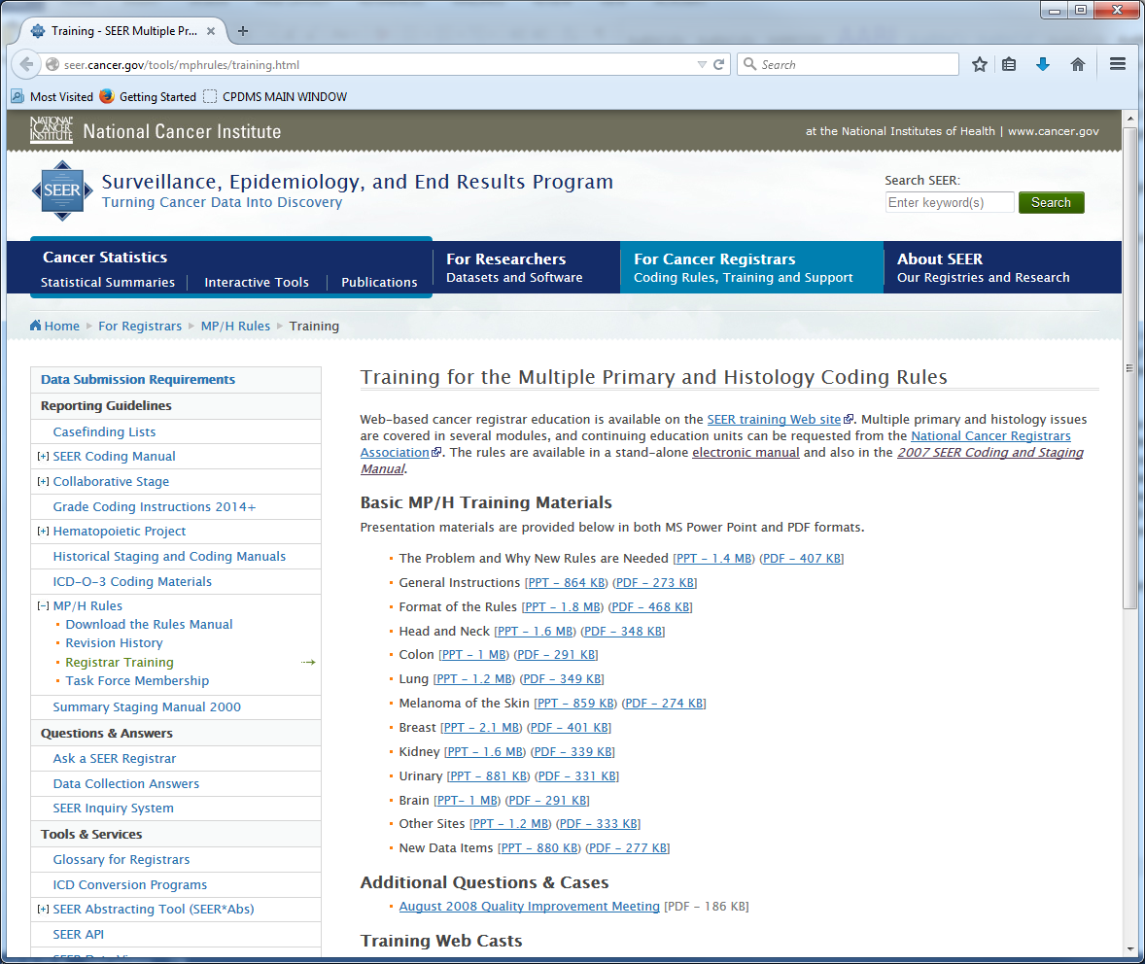
The 2007 Multiple Primary and Histology Coding Rules contain site-specific rules for lung, breast, colon, melanoma of the skin, head and neck, kidney, renal pelvis/ureter/bladder, benign brain, and malignant brain. A separate set of rules addresses the specific and general rules for all other sites. The multiple primary rules guide and standardize the process of determining the number of primaries. The histology rules contain detailed histology coding instructions. For example, grouping histologic terms, differentiating between general (NOS) terms and specific histologic types and subtypes, and identifying mixed and combination codes are covered. The MP/H Task Force also developed three new data items that complement these rules.
Please visit the coding manual download page to obtain a copy of the Multiple Primary and Histology Coding Rules Manual.

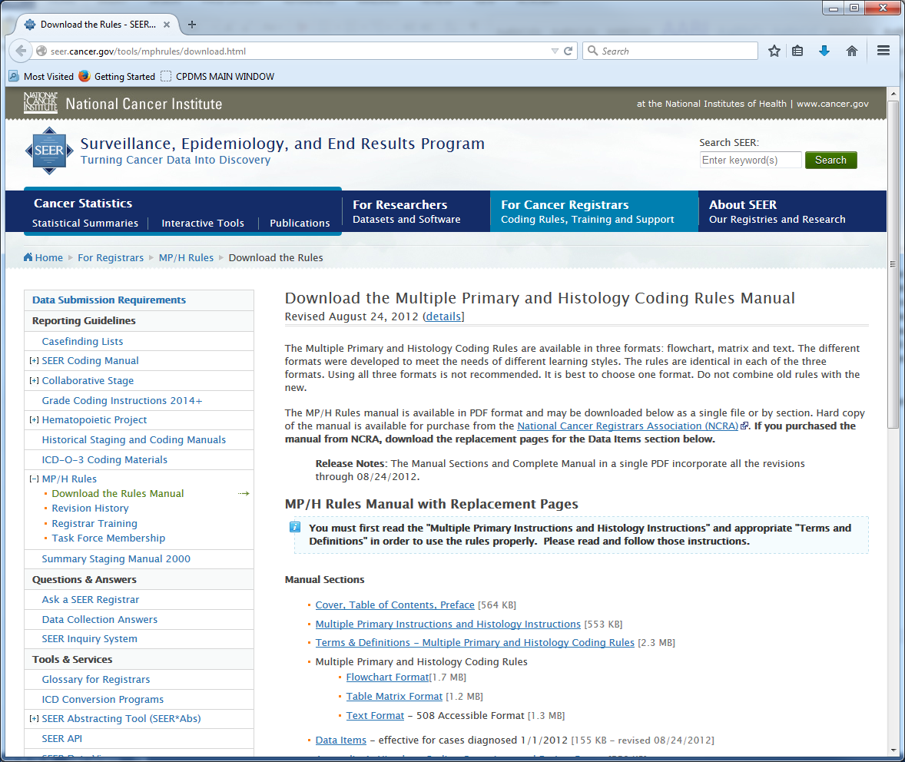
SEER training webcasts for MP/H – Introduction: http://www.training.seer.cancer.gov/coding/neoplasms/

SINQ I & R

http://seer.cancer.gov/seerinquiry/index.php

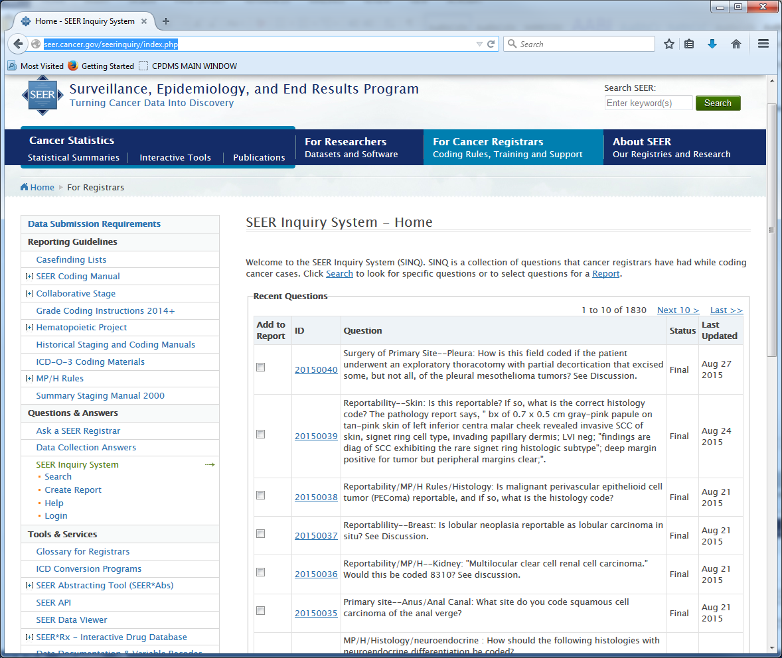

SEER Appendix C
https://seer.cancer.gov/manuals/2016/appendixc.html

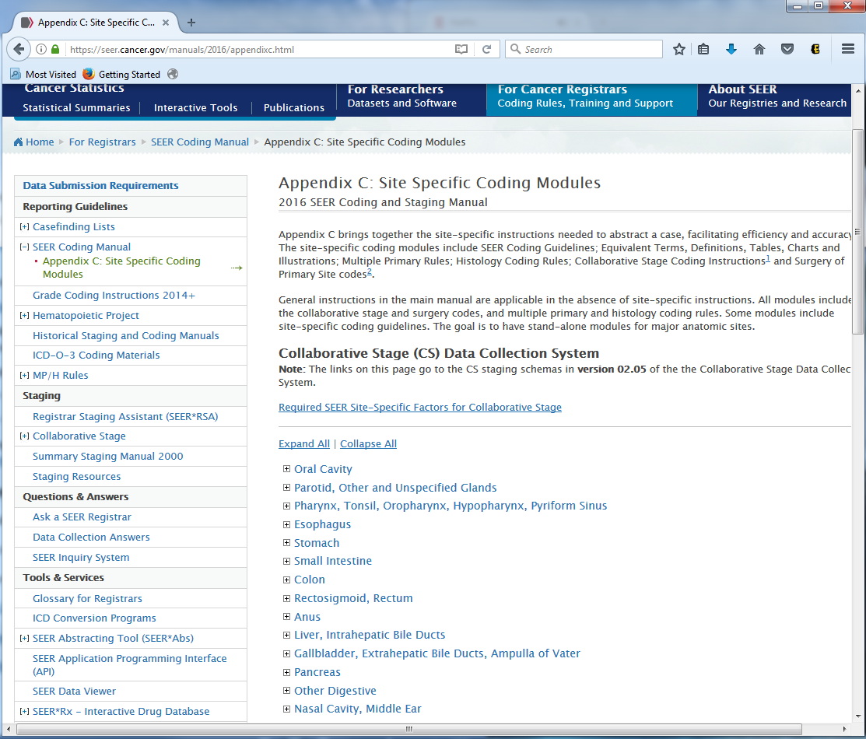

SEER Educate

This is a good resource for education and sharpening skills. There are a wide variety of topics that will help you in preparation for your CTR exam and in preparation for abstracting cases.
https://educate.fhcrc.org/Index.aspx
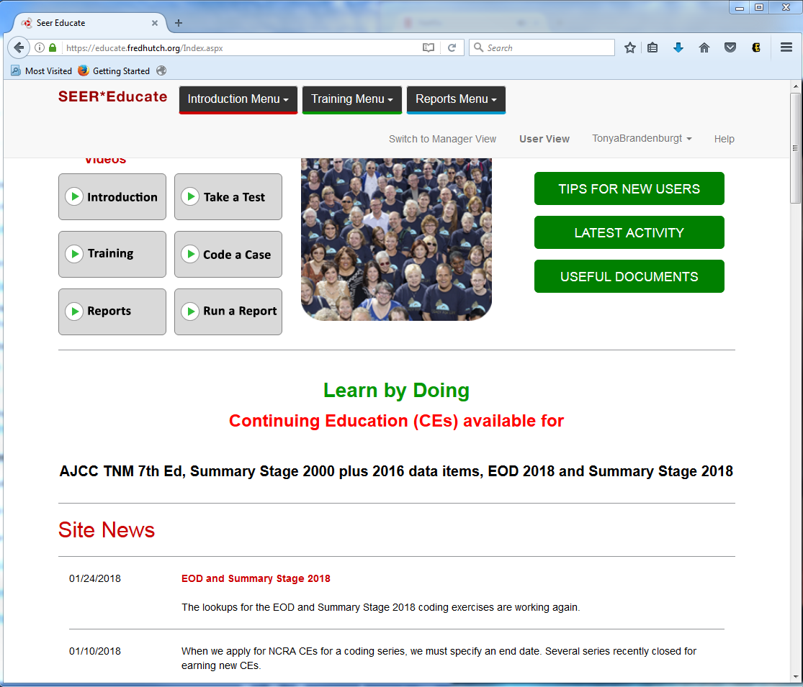

Fords Manual including surgery codes

https://www.facs.org/quality-programs/ccer/ncdb/registrymanuals/cocmanuals/fordsmanual

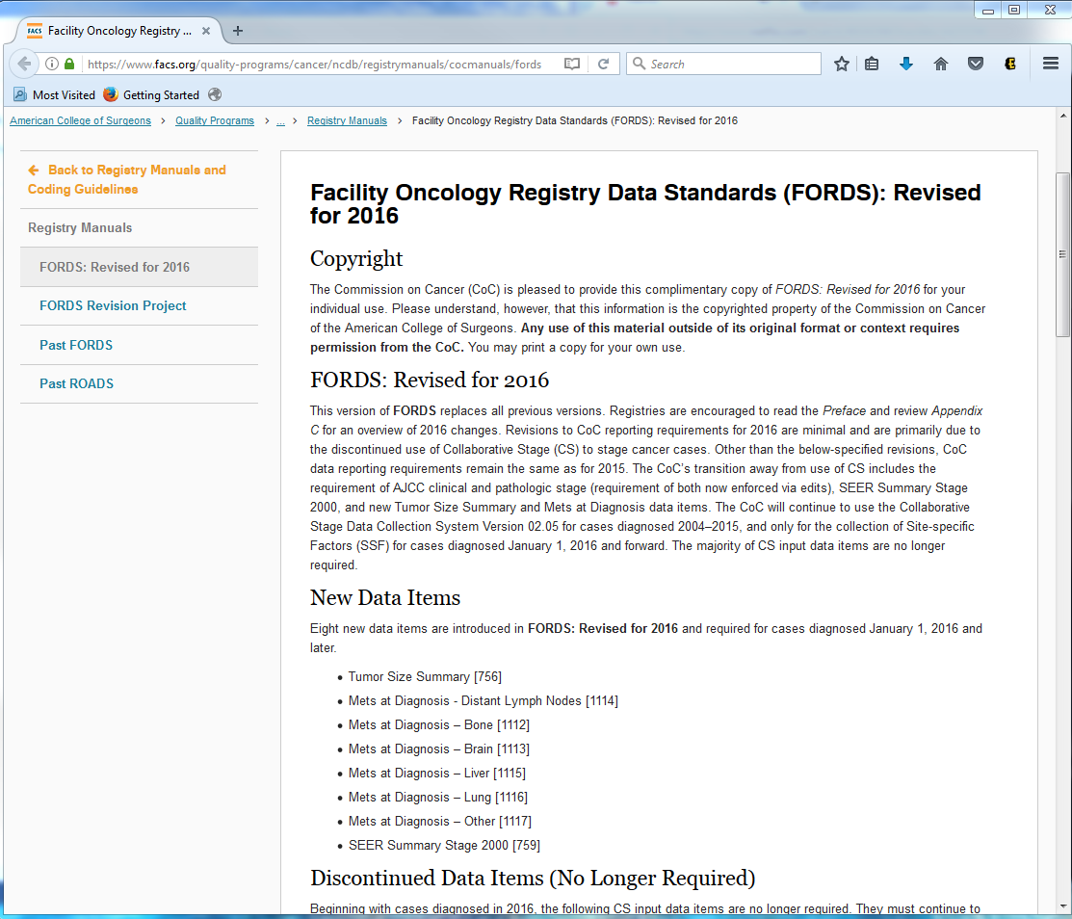

CoC Program standards Manual/website

https://www.facs.org/quality-programs/cancer/coc/standards

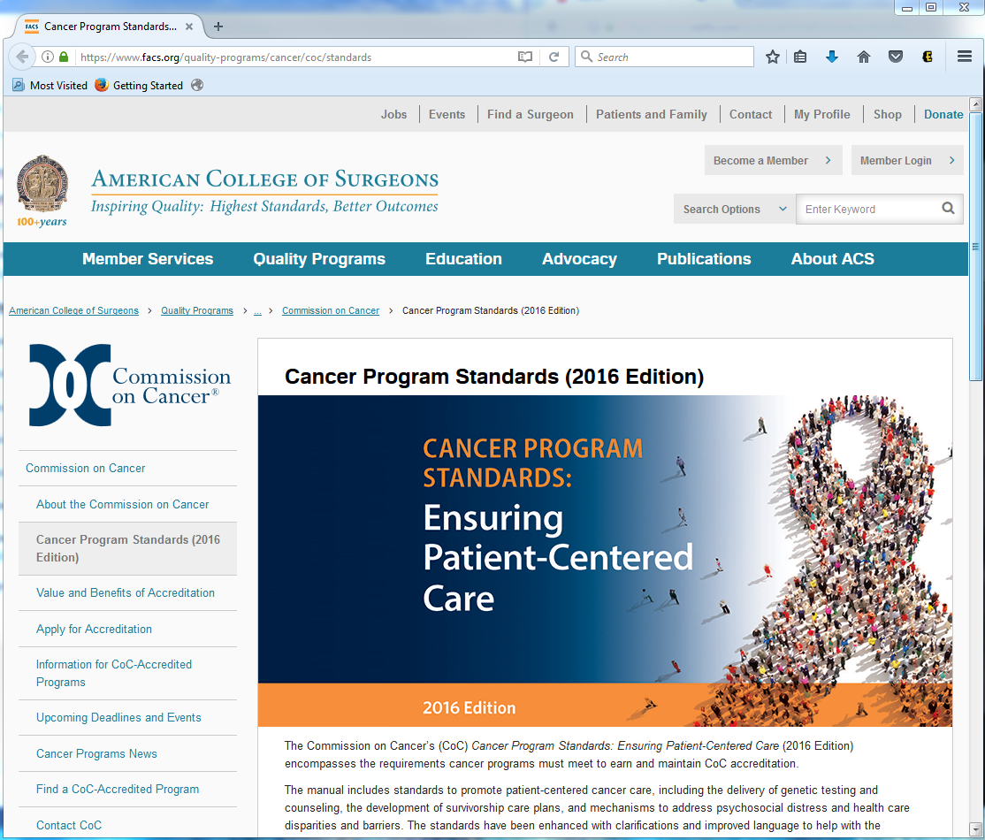

Hematopoietic & Lymphoid Neoplasm Case and Reportability and Coding Manual
This site provides data collection rules for hematopoietic and lymphoid neoplasms for 2010+. There are two tools for use with these rules:
- Hematopoietic & Lymphoid Neoplasm Database (Heme DB)
  - A tool to assist in screening for reportable cases and determining reportability requirements
  - The database contains abstracting and coding information for all hematopoietic and lymphoid neoplasm (9590/3-9992/3)
- Hematopoietic & Lymphoid Neoplasm Coding Manual
  - Reportability instructions and rules for determining the number of primaries, the primary site and histology, and the cell lineage or phenotype
  - The introduction to the manual has an updated Steps in Priority Order for using the Hematopoietic and Lymphoid Neoplasm Coding Manual & Database.
The Heme DB is available in two formats: as a web-based tool and as stand-alone software.

Web-based Version of the Database
The Heme DB provided in a web-based format has several benefits over the software version:
- Updates are automatic: users do not have to install anything to access the latest revisions.
- Allows access from any computer or device with an Internet connection.
- Eliminates problems for users who do not have permission to install software on their work computers.
Hematopoietic and Lymphoid Neoplasm Database and Coding Manual - For cases diagnosed January 1, 2010 and later.
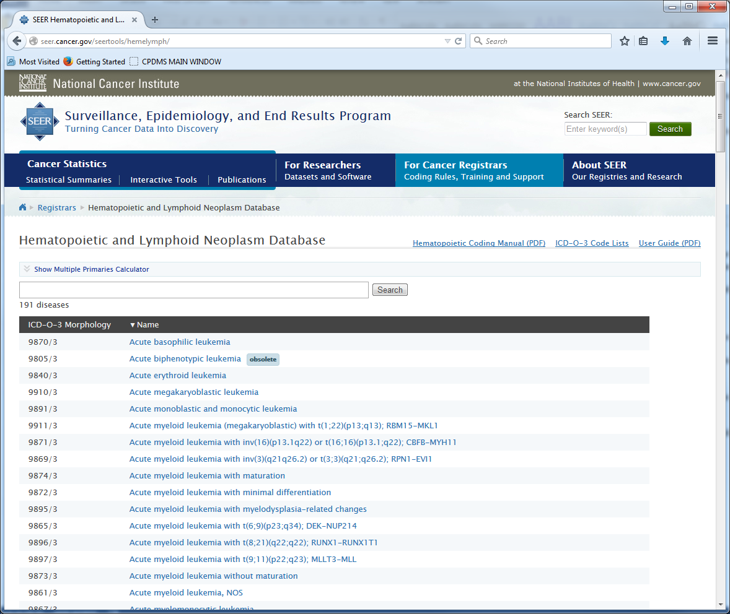

CAnswer Forum

http://cancerbulletin.facs.org/forums/

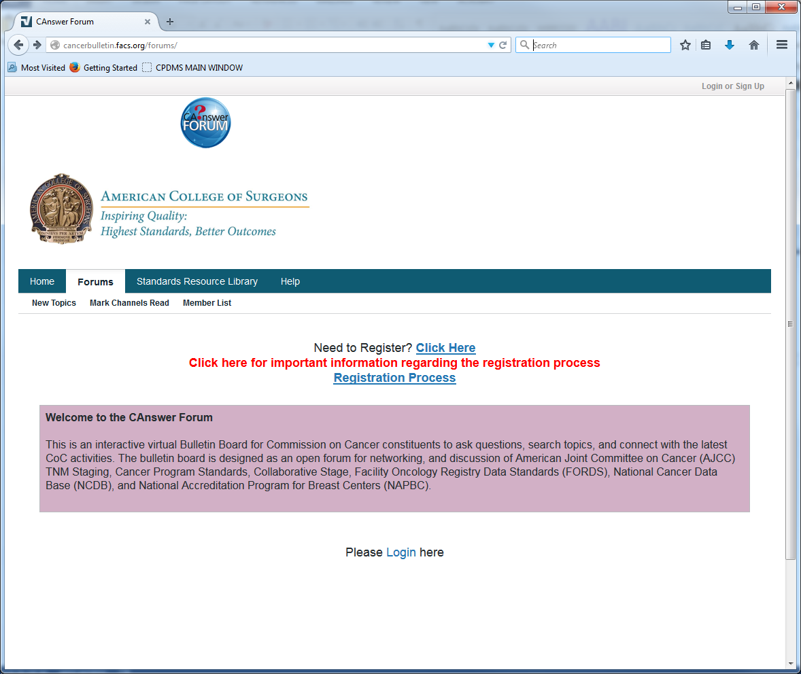

NAACCR (North American Association of Central Cancer Registries)

http://www.naaccr.org/

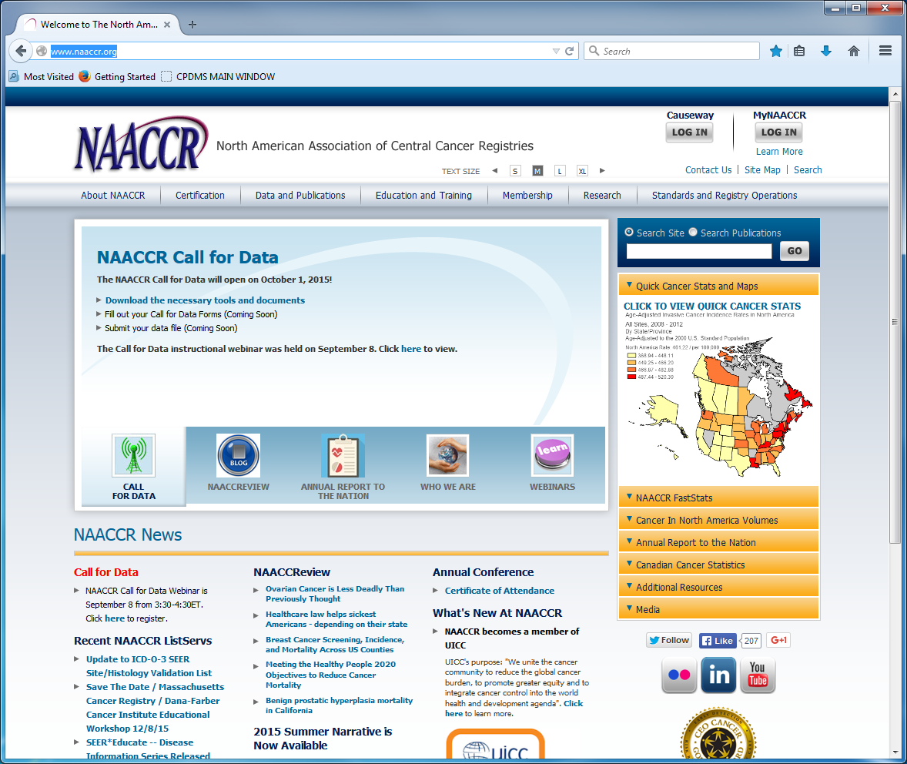

NCRA (National Cancer Registrars Association)

http://www.ncra-usa.org/

CAP protocols and references

http://www.cap.org/web/oracle/webcenter/portalapp/pagehierarchy/cancer_protocol_templates.jspx?_afrLoop=2036381384481933#!%40%40%3F_afrLoop%3D2036381384481933%26_adf.ctrl-state%3Danzapys6m_14

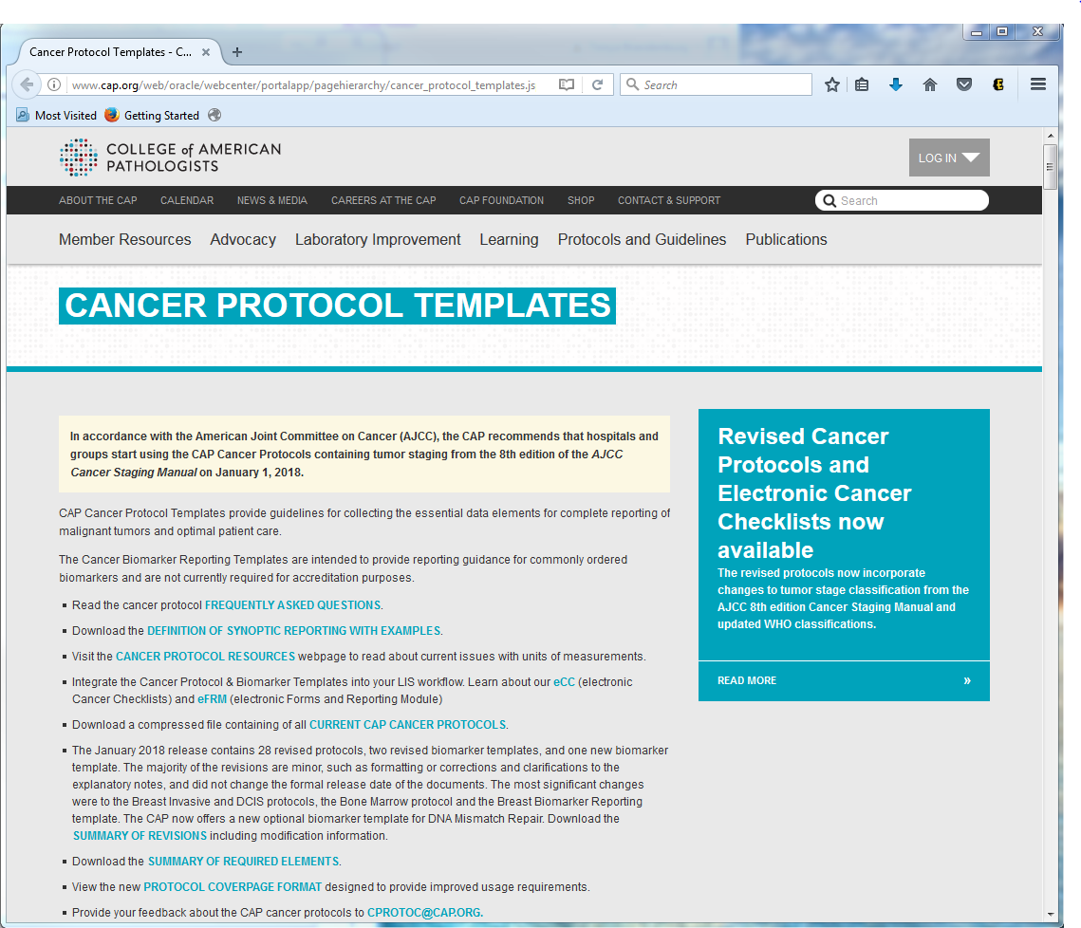

NCCN Guidelines

http://www.nccn.org/professionals/physician_gls/f_guidelines.asp

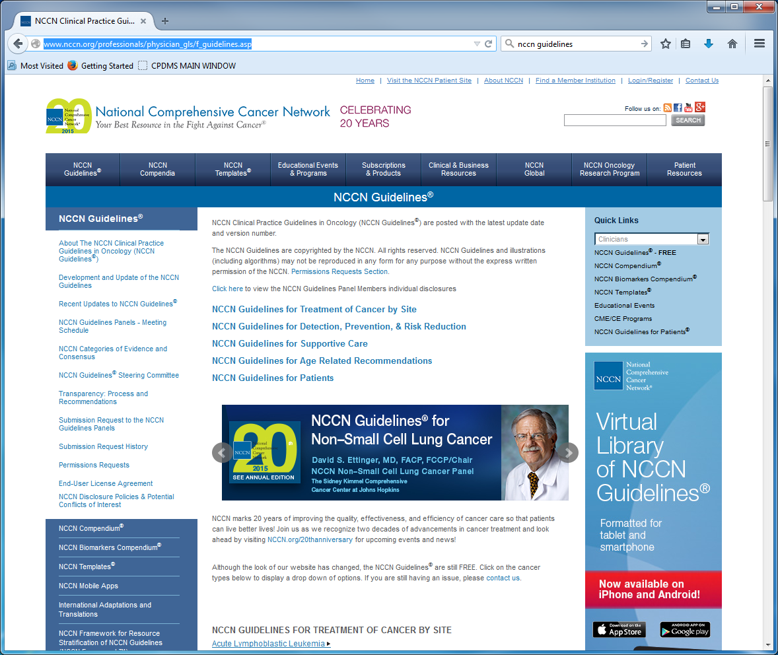

New Abstractor’s Training and Operator’s Training

New Abstractor’s Training is usually 2-3 days and Operator’s Training is 1-2 days depending on the needs of those attending training.

KCR Regional Coordinator Site Visits and Processes

Periodically, your KCR regional coordinator will visit on site to share communication from KCR, QA results, and the facilities progress towards maintaining the state’s standards for registry operations. During the site visit, your regional coordinator will be available to meet with the registry supervisor/manager. Regional coordinators can be contacted by email for any questions or concerns.

CPDMS Summary Reports

During your site visit, your regional coordinator will provide a summary report that includes a CPDMS timeliness and completeness report, QA info, and follow-up rates.

Errata Reports

Erratas occur when two or more facilities are bringing in the same patient or abstract but there are conflicting codes or dates. Some of the reasons for the conflicts could be one facility had better treatment information (since that particular facility performed work up there or that one facility had very minimal information regarding cancer workup or treatment information in chart). Often an errata can occur when the reporting facility does not know about previous cancer diagnoses and inadvertently assigns the wrong sequence number to the case abstracted at that facility.
Erratas are generated once monthly for each facility. It is important to have your erratas corrected before the next monthly upload since the outstanding erratas will continue to appear on your errata list until corrected.
If you have questions regarding your erratas or if you need further information then please call Desiree at 859-218-6977

KCR Spring Training and Fall Workshop

Each year KCR gives a Spring Training and a Fall Workshop. The Spring Training usually covers changes for the coming year and other pertinent information and is conducted via webinar. The Fall Workshop is held for 1.5 days as an in-person meeting and features speakers from different cancer subjects, KCR staff, and KCR IT Staff.

Epath Audits from Lisa Witt

Twice a year, KCR will audit each facilities ePath reports against cases in the central database. We will select records from 18 months prior to the current abstracting cycle. For instance, if you are abstracting the first half of 2015, path reports from the second half of 2013 will be audited.
All of the records from that time period will be matched against existing cases in the KCR Central database. If there are path reports with a positive findings for cancer but no matching cases in your local database, KCR will return those cases to your registry for resolution
We will want to know if you:
A. missed the case
B. found the case in your local database (maybe with a different name or SSN)
C. resolved the case as being NOT REPORTABLE to your facility.
Lists of audit cases will be sent to your registry Jan 1 and June 1.

Casefinding Audits and Possible Missed Cases from Vicki LaRue

KCR performs casefinding audits as part of routine quality assurance studies. These audits ensure all cancer cases are reported as mandated by state law. A summary of the audit results and any recommendations for improvement are mailed to the facility at the conclusion of the audit process. Casefinding audits are simply another tool to aid hospital registries in achieving and maintaining the highest possible standards for cancer reporting in Kentucky.

Throughout the year the registry may identify possible missed cases at a facility through our NHF coordinators or other resources. Vicki maintains a list of these cases and sends the list out to hospitals quarterly for resolution.

Death Clearance Follow-back from Lindsey Baker

Once a year you will received death clearance follow back forms from Lindsey Baker. These forms are for patients that died at your facility or have been associated with your facility for a cancer that is not reported in the central registry at this time. It is important to review these cases and send them back to KCR in a timely manner, so that we may get them resolved.

Text Templates for Entering Cases

TEXT DOCUMENTATION EXAMPLE #1

Physical Exam

67 yo wf w/ HX of abdominal pain and rectal bleeding; HX of L Breast ca DX’d in 1999 (8500/3, ER/PR+) s/p LMRM & Chemo, T1cN0M0 Stage IA (Seq #1); No FHX of cancer; Post-men; Live Births=2; +Smoker 1 ppd x 50 yrs = 50 ppy HX; ETOH unk; “PE: abdomen very tender w/ no distention noted.” – per ER records dated 1/1/13. SS# XXX-XX-XXXX checked and verified on medicare ins card.

NC (4/30/13)

Xrays and Scans

1/5/2013(X HOSPITAL)-CT ABDOMEN/PELVIS – “There is thickening of the ascending colon noted w/ stranding of the pericolonic tissues that could be related to malignancy or infection. No mass or lesion is identified in this scan. There is possible nodal metastasis identified. No liver lesions identified.”

1/12/2013(X HOSPITAL)-CT CHEST – “No indication of METS.”

NC (4/30/13)

Scopes

1/8/2013(X HOSPITAL)-COLONOSCOPY – “There was an approximately 4.5 cm mass located in the ascending colon. The mass was circumferential. BX was obtained. The remainder of the colon was normal.”(DATE OF DX)(DFC)(COC 13).

NC (4/30/13)

Labs

1/8/2013(X HOSPITAL)- CEA = 22.9 ng/mL (H); elevated based on normal lab values listed on the lab report; also stated to be elevated by surgeon in H&P.

NC (4/30/13)

OP reports

1/15/2013(X HOSPITAL)-LAP R HEMICOLECTOMY- “The tumor was identified in the mid ascending colon. The colon was mobilized and the transverse colon was transected. The ileum was divided. The specimen was removed.”(COC 13).

NC (4/30/13)

Path reports

1/8/2013(X HOSPITAL)- X13-XXXX – FINAL DIAGNOSIS:

ASCENDING COLON BIOPSY: INVASIVE ADENOCARCINOMA, INVASION CANNOT BE DETERMINED BASED ON THIS LIMITED BIOPSY.

1/15/2013(X HOSPITAL)- X13-XXXX – FINAL DIAGNOSIS:

TUMOR SITE: ASCENDING COLON

TUMOR HISTOLOGY: ADENOCARCINOMA

TUMOR GRADE: LOW GRADE

TUMOR SIZE: 5.7 CM

TUMOR EXTENT: TUMOR INVADES MUSCULARIS PROPRIA AND EXTENDS INTO PERICOLIC ADIPOSE TISSUE.

NO INVOLVEMENT OF SEROSA IS IDENTIFIED.

TUMOR DEPOSITS: NOT IDENTIFIED.

LYMPH/VASCULAR INVASION: PRESENT.

PERINEURAL INVASION: PRESENT.

MARGINS: ALL MARGINS ARE NEGATIVE.

DISTANCE FROM CLOSEST MARGIN: 3 CM FROM THE PROXIMAL MARGIN.

LYMPH NODES: 3 OF 15 LYMPH NODES POSITIVE FOR METASTATIC ADENOCARCINOMA.

PATHOLOGIC AJCC STAGING: pT3N1bMn/a.

GROSS DESCRIPTION:

…The tumor is located 6 cm from the circumferential radial margin…

NC (4/30/13)

Site Text

C18.2 Ascending Colon per OP report.

NC (4/30/13)

Histology Text

M8140/3 Adenocarcinoma, grade 2 per path.

-Conclusive Terminology.

-MPH Rule H11.

NC (4/30/13)

Staging

Single Tumor – Rule M2.

CSTS 057 Tumor size 5.7 cm per path.

CSEXT 450 Tumor invades muscularis propria w/extension into pericolic adipose tissue per path.

CS TS/EXT EVAL 3 Pathologic.

CSLN 300 Involvement of regional lymph nodes, nos per path.

LN EVAL 3 Pathologic.

LN+ 3 per path.

LN EXAM 15 per path.

METS@DX 00 No distant METS per scans.

METS EVAL 0 Clinical per scans.

(SSF1) 010 CEA elevated per H&P 1/17/13 (SSF2) 000 LNS clinically negative per CT (SSF3) 229 CEA 22.9 ng/mL (SSF4) 000 No tumor deposits identified per path (SSF5) 998 No preop treatment performed (SSF6) 600 CRM 6 cm per path (SSF7) 999 MSI unknown (SSF8) 010 Perineural invasion present per path (SSF9) 999 KRAS unknown (SSF10) 999 18q LOH unknown

Registrar stages: cTxN0M0 Stage unknown, pT2N1b Stage IIIB.

MD stages: cTxN0M0 Stage unknown, pT2N1b Stage IIIB; documented on AJCC staging form.

NC (4/30/13)

General Remarks

DLC 3/30/2013 CT scan per EMR.

PT alive, cNED per CT scan.

1/25/13(OUTSIDE ONCOLOGY OFFICE)- POSTOP CHEMO = FOLFOX-6.(COC 13). – per MD office staff.

PT is being followed by Dr. X (Med Onc), Dr. X (Surgeon), Dr. X (GI) and Dr. X (PCP) for Ascending Colon Adenocarcinoma (Seq #2).

NC (4/30/13)

TEXT DOCUMENTATION EXAMPLE #2

Physical Exam

71 yo wm w/ HX of an abnormal screening colonoscopy; No FHX of cancer; Non-smoker; ETOH unk; SS# XXX-XX-XXXX checked and verified on medicare ins card.

NC (4/30/13)

Xrays and Scans

2/7/2013(X HOSPITAL)-CT ABDOMEN/PELVIS – “There is thickening of the sigmoid colon noted with induration of the mesenteric fat that could be related to malignancy. No mass or lesion is identified in this scan. There is possible nodal metastasis identified. There is a liver mass identified that is suspicious for metastasis.”

2/10/2013(X HOSPITAL)-CT CHEST – “There are multiple nodules in both lungs consistent with metastases.”

NC (4/30/13)

Scopes

2/4/2013(OUTSIDE FACILITY)-COLONOSCOPY – “There was an approximately 5.9 cm mass located in the sigmoid colon. The mass was circumferential. BX was obtained. The remainder of the colon was normal.”(DATE OF DX)(COC 21).

NC (4/30/13)

Labs

2/7/2013(X HOSPITAL)- CEA = 58.9 ng/mL (H); elevated based on normal lab values listed on the lab report; also stated to be elevated by surgeon in H&P.

NC (4/30/13)

OP reports

2/13/2013(X HOSPITAL)-LAP L HEMICOLECTOMY & TRU-CUT LIVER BIOPSY- “The tumor was identified in the sigmoid colon. The colon was mobilized and the transverse colon was transected. The rectosigmoid colon was divided. The specimen was removed. A Tru-cut liver biopsy was performed of a suspicious liver mass.”(COC 21).

NC (4/30/13)

Path reports

2/4/2013(X HOSPITAL)- X13-XXXX – FINAL DIAGNOSIS:

SIGMOID COLON BIOPSY: INVASIVE ADENOCARCINOMA WITH MUCINOUS FEATURES.

2/13/2013(X HOSPITAL)- X13-XXXX – FINAL DIAGNOSIS:

PROCEDURE PERFORMED: LEFT HEMICOLECTOMY (SPECIMEN A) & TRU-CUT LIVER BIOPSY (SPECIMEN B).

SPECIMEN A:

TUMOR SITE: SIGMOID COLON

TUMOR HISTOLOGY: MUCINOUS ADENOCARCINOMA.

TUMOR GRADE: HIGH GRADE.

TUMOR SIZE: 7.2 CM

TUMOR EXTENT: TUMOR INVADES MUSCULARIS PROPRIA WITH EXTENSION INTO PERICOLIC ADIPOSE TISSUE.

TUMOR INVADES THE SEROSA.

TUMOR DEPOSITS: NOT IDENTIFIED.

LYMPH/VASCULAR INVASION: PRESENT.

PERINEURAL INVASION: PRESENT.

MARGINS: ALL MARGINS ARE NEGATIVE.

DISTANCE FROM CLOSEST MARGIN: 2.1 CM FROM THE CIRCUMFERENTIAL RADIAL MARGIN.

LYMPH NODES: 15 OF 17 LYMPH NODES POSITIVE FOR METASTATIC MUCINOUS ADENOCARCINOMA.

SPECIMEN B:

LIVER, TRU-CUT BIOPSY: METASTATIC MUCINOUS ADENOCARCINOMA.

NC (4/30/13)

Site Text

C18.7 Sigmoid Colon per OP report.

NC (4/30/13)

Histology Text

M8480/3 Mucinous Adenocarcinoma, grade 4 per path.

-Conclusive Terminology.

-MPH Rule H5.

NC (4/30/13)

Staging

Single Tumor – Rule M2.

CSTS 072 Tumor size 7.2 cm per path.

CSEXT 550 Tumor invades muscularis propria w/extension into pericolic adipose tissue (450) + invasion of serosa (500) per path.

CS TS/EXT EVAL 3 Pathologic.

CSLN 300 Involvement of regional lymph nodes, nos per path.

LN EVAL 3 Pathologic.

LN+ 15 per path.

LN EXAM 17 per path.

METS@DX 36 Distant METS to liver and lung per Tru-cut liver BX path & CT scans.

METS EVAL 0 Clinical per CT showing lung METS.

(SSF1) 010 CEA elevated per H&P 1/17/13 (SSF2) 000 LNS clinically negative per CT (SSF3) 589 CEA 58.9 ng/mL (SSF4) 000 No tumor deposits identified per path (SSF5) 998 No preop treatment performed (SSF6) 210 CRM 2.1 cm per path (SSF7) 999 MSI unknown (SSF8) 010 Perineural invasion present per path (SSF9) 999 KRAS unknown (SSF10) 999 18q LOH unknown

Registrar stages: cTxN0M1b Stage IVB, pT4aN2bM1a Stage IVA.

MD stages: cTxN0M1b Stage IVB, pT4aN2bM1a Stage IVA; documented on AJCC staging form.

NC (4/30/13)

General Remarks

DLC 4/1/2013 CT scans showing progression of liver & lung METS per EMR.

PT alive, Cancer present per scans.

2/23/13(OUTSIDE ONCOLOGY OFFICE)- POSTOP IMMUNOTHERAPY = FOLFOX/Avastin.(COC 21). – per MD office staff.

PT is being followed by Dr. X (Med Onc), Dr. X (Surgeon), Dr. X (GI) and Dr. X (PCP) for Sigmoid Colon Mucinous Adenocarcinoma (Seq #1).

NC (4/30/13)

NOTE: The liver mass was biopsied and showed adenocarcinoma; if this was the only site of METS than you would code METS eval as 3 and it would derive a pM1a (single organ). Since you have liver and lung METS and the lung nodules were not biopsied than you will code METS eval as 0 clinical based on the CT scans and this will derive a cM1b (multiple organs).

Links

CPDMS - https://cpdms.net/cpdms/

KCR website – www.kcr.uky.edu
KCR Manuals – www.kcr.uky.edu/manuals
FES - https://fes.uky.edu
Registrar’s Wiki - https://confluence.kcr.uky.edu/display/kentuckyregistrarswiki/Kentucky+Registrars+Wiki
KCR Portal - https://portal.kcr.uky.edu/
Case Reportability Requirements - https://www.kcr.uky.edu/manuals/cpdms-help/Introduction/case_reporting_requirements.htm
Casefinding List – https://confluence.kcr.uky.edu/display/KAM/Casefinding
SEER Casefinding List - https://seer.cancer.gov/tools/casefinding/case2018-icd10cm.html
CTR Exam Resources - http://www.ctrexam.org/resources/index.htm
Collaborative Staging and AJCC Instructions - https://cancerstaging.org/cstage/Pages/default.aspx

April Fritz Case books I and II - http://www.afritz.org/
SEER Module for Follow Up - http://www.training.seer.cancer.gov/followup/

Multiple Primary and Histology Rules - https://seer.cancer.gov/tools/mphrules/download.html

SEER Cancer Registrar Training - https://seer.cancer.gov/training/

SEER Educate - https://educate.fredhutch.org/LandingPage.aspx

SINQ I & R - http://seer.cancer.gov/seerinquiry/index.php

SEER Appendix C - https://seer.cancer.gov/manuals/2016/appendixc.html

FORDS Manual - https://www.facs.org/quality-programs/cancer/ncdb/registrymanuals/cocmanuals/fordsmanual

COC Program Standards Manual - http://cancerbulletin.facs.org/forums/

NAACCR (North American Association of Central Cancer Registries) - http://www.naaccr.org/

NCRA (National Cancer Registrars Association) - http://www.ncra-usa.org

CAP protocols and references - http://www.cap.org/web/oracle/webcenter/portalapp/pagehierarchy/cancer_protocol_templates.jspx?_afrLoop=2036381384481933#!%40%40%3F_afrLoop%3D2036381384481933%26_adf.ctrl-state%3Danzapys6m_14

NCCN Guidelines - http://www.nccn.org/professionals/physician_gls/f_guidelines.asp

USPS Address and Zip Code Check - https://tools.usps.com/go/ZipLookupAction!input.action

